**✨Chapter 13: Stress ✨**

**Health Psychology** is the branch of psychology which explores the relationship between psychological factors and physical ailments or disease. This branch observes human beings in the following domains which influence illness and health: Behavior, Biology & Social context

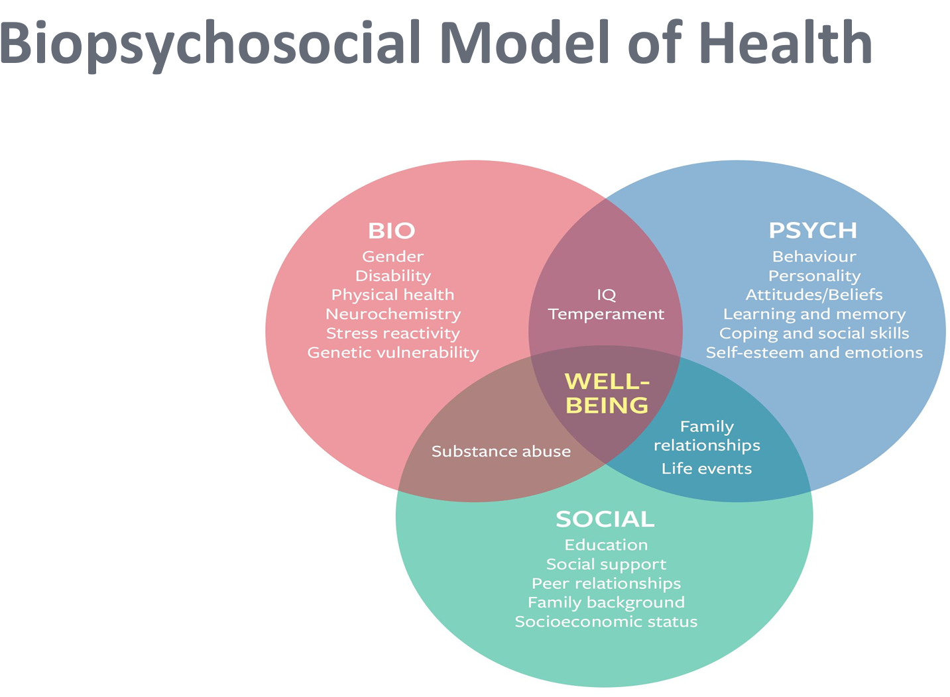

**Normal vs Abnormal Perspectives**

**Humanistic ideals of Greek**: Madness is an illness that should be treated in asylums by being confined there rather tortured.

**Medical Perspective**: Abnormal behavior has biochemical or physiological basis.

**Psychoanalytic model**: Behavior disorders are symbolic expressions of internal conflicts.

**Behavioral/ Learning theory model**: The model states that abnormal behavior, like other behavior, is the result of learning. •The only thing that separates the normal from the sick is Experience

**Cognitive model**: This model postulates that people’s thoughts and beliefs are central to a person’s abnormal behavior. A primary goal of treatment using the cognitive perspective is to explicitly teach new, more adaptive ways of thinking. Example: Erroneous belief: “doing well on this exam is crucial to my entire future”. Realistic and less anxiety-producing thought: “my entire future is not dependent on this one exam.”

**CONFLICT AND FRUSTRATION**

**Frustration** occurs in any situation in which the pursuit of some goal is thwarted. In essence, you experience frustration when you want something and you can’t have it.

**Conflict:** Like frustration, conflict is an unavoidable feature of everyday life. The perplexing question “Should I or shouldn’t I?” comes up countless times in everyone’s life. Conflict occurs when two or more incompatible motivations or behavioral impulses compete for expression.

**Types of conflicts:**

* **Approach-approach conflict:** In an approach-approach conflict a choice must be made between two attractive goals. The problem, of course, is that you can choose just one of the two goals. For example: You have a free afternoon; should you play tennis or racquetball? You can’t afford both. Among the three kinds of conflict, the approach-approach type tends to be the least stressful. People don’t usually stagger out of restaurants exhausted by the stress of choosing which of several appealing entrees to eat. Nonetheless, approach-approach conflicts over important issues may sometimes be troublesome. If you’re torn between two ap pealing college majors or two attractive boyfriends, you may find the decision-making process quite stressful, since whichever alternative is not chosen represents a loss of sorts.
* **Avoidance-avoidance conflict:** In an avoidance-avoidance conflict a choice must be made between two unattractive goals. For example, should you continue to collect unemployment checks, or should you take that degrading job at the car wash? Or suppose you have painful backaches. Should you submit to surgery that you dread, or should you continue to live with the back pain? Obviously, avoidance-avoidance conflicts are most unpleasant and highly stressful.
* **Approach-avoidance conflict:** In an approach-avoidance conflict a choice must be made about whether to pursue a single goal that has both attractive and unattractive aspects. For instance, imagine that you’re offered a career promotion that will mean a large increase in pay, but you’ll have to move to a city where you don’t want to live. Approach-avoidance conflicts are common and can be quite stressful. Any time you have to take a risk to pursue some desirable outcome, you’re likely to find yourself in an approach-avoidance conflict. Approach-avoidance conflicts often produce *vacillation*. That is, you go back and forth, beset by indecision. You decide to go ahead, then you decide not to, then you decide to go ahead again. Humans are not unique in this respect.

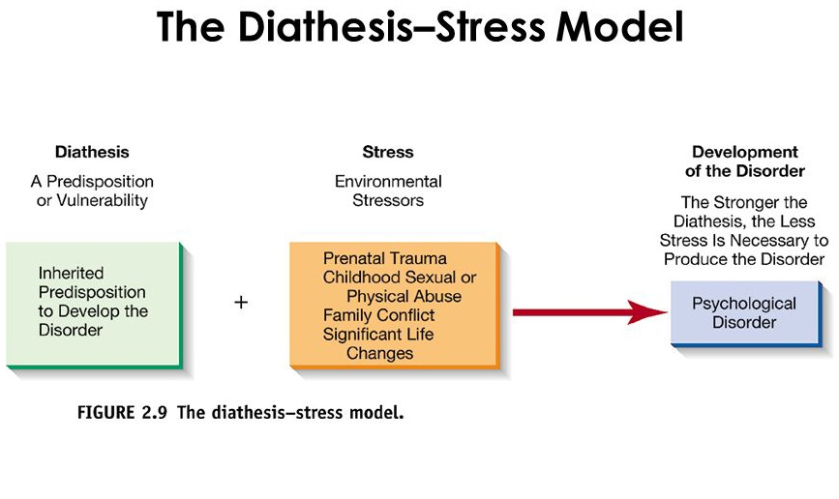

**Diathesis:** Diathesis refers to an inherited predisposition or vulnerability to developing a psychological disorder. It is the internal factor that makes someone more susceptible to mental health problems. This can be:Genetic factors: Inherited traits or genetic makeup, Biological vulnerabilities: Issues like imbalances in brain chemistry or hormone regulation.The presence of this vulnerability alone is usually not enough to cause a disorder; the individual may never experience the disorder unless additional factors contribute.

**2. Stress:** Stress refers to environmental stressors or life events that act as triggers for psychological disorders. These can include:Prenatal trauma: Stress or harm during pregnancy that can affect a child's development, Childhood sexual or physical abuse: Early traumatic events that increase vulnerability, Family conflict: Ongoing issues or dysfunction within the family, Significant life changes: Events like moving, losing a job, or the death of a loved one.

**3. Development of the Disorder:** The interaction of both diathesis (predisposition) and stress (external triggers) leads to the development of a psychological disorder. The model suggests that:

* + The stronger the diathesis (vulnerability), the less stress is needed to develop the disorder. This means that people with a high predisposition to mental illness may experience a disorder with only minor stressors.
  + Conversely, someone with a lower vulnerability may require more significant or prolonged stress to develop the disorder.

**Stress**: Any circumstances that threaten or are perceived to threaten one’s well-being and that thereby tax one’s coping abilities or its defined as physical or psychological threat to an organism or system and the reaction to that threat

**MAJOR TYPES OF STRESS:**

**Acute stressors**: are threatening events that have a relatively short duration and a clear endpoint. Examples would include having an encounter with a belligerent drunk, dealing with the challenge of a major exam, or having your home threatened by severe flooding.

**Chronic stressors**: are threatening events that have a relatively long duration and no readily apparent time limit. Examples would include persistent financial strains produced by huge credit card debts, ongoing pressures from a hostile boss at work, or the demands of caring for a sick family member over a period of years.

1. **Eustress:** It is a positive stress. Eustress can promote feelings of energy, focus, excitement or fulfillment. It is typically caused by positive experiences, such as starting a new job or getting married. It helps with motivation and working toward goals.
2. **Distress:** It is a negative stress that causes feelings of worry, fear or anxiety. Distress can cause physical symptoms such as chest pain, headaches, digestive issues, or insomnia. It can also worsen or cause serious health conditions, such as heart disease.
3. **Hyper-stress:** It refers to high levels of stress which may lead to panic attacks,   
   frustration, or exaggerated reactions.
4. **Hypo-stress:**  It refers to an insufficient amount of stress which leads to under stimulation and the person gets bored, restless, and demotivated.

**Causes/ Sources of Stress**

**Stressor** is the actual event or cause of why someone may be experiencing stress.

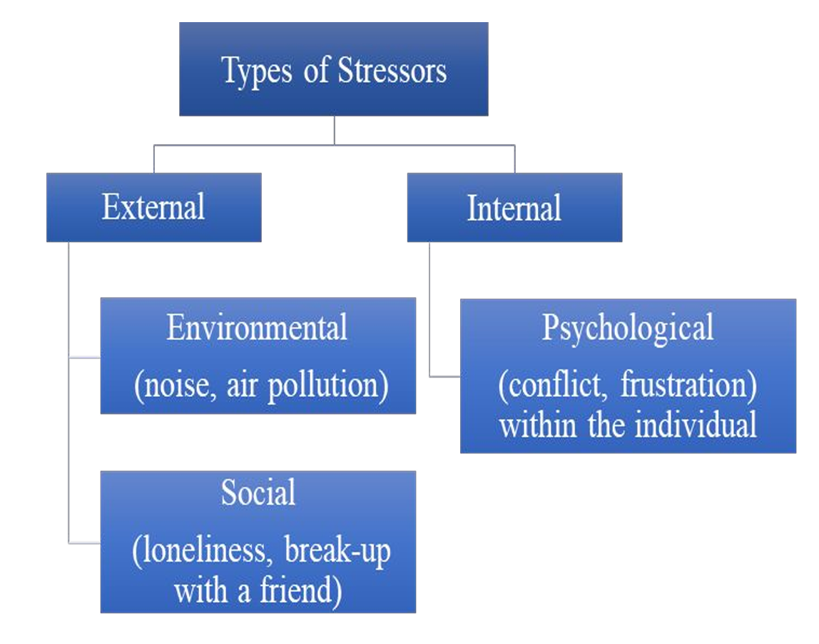 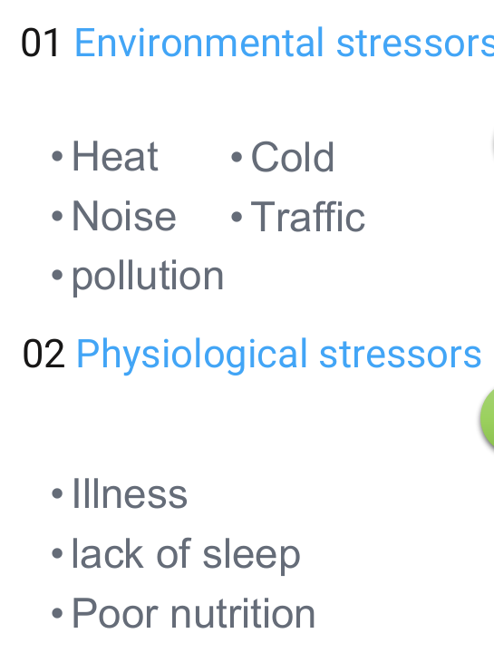 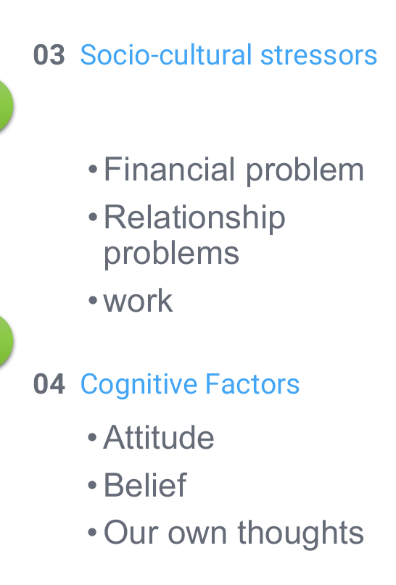

**SYMPTOMS OF STRESS**

**Behavioral:** Sleep disturbance Use of alcohol/drugs Absenteeism Aggression

**Physiological:** Higher blood pressure Rapid shallow breathing Increased heart rate Dilation of pupils Muscle tension Dry mouth

**Biochemical:** Increased metabolic rate Altered hormone levels (adrenaline, cortisol, ACTH) Altered endorphin levels

**Emotional:** Depression/anxiety Irritability Crying , Suicide Loss of humour

**Cognitive:** Lack of concentration Negative thoughts Worrying Poor Memory

**Negative Effects of Stress:**

Generate unpleasant emotion ,Promoting negative thinking , Narrowing attention, Preoccupation, It consumes mental energy, Interpersonal problem, Lack of motivation, Reduce performance

**Positive Effects of Stress:**

Prepare the body to meet challenges. Stress is a source of energy Physiological arousal and alertness. It increases performance

**Responding to Stress**

When you groan in reaction to the traffic report, you’re experiencing an emotional response to stress, in this case annoyance and anger. When your pulse quickens and your stomach knots up, you’re exhibiting physiological responses to stress. When you shout insults at another driver, your verbal aggression is a behavioral response to the stress at hand. 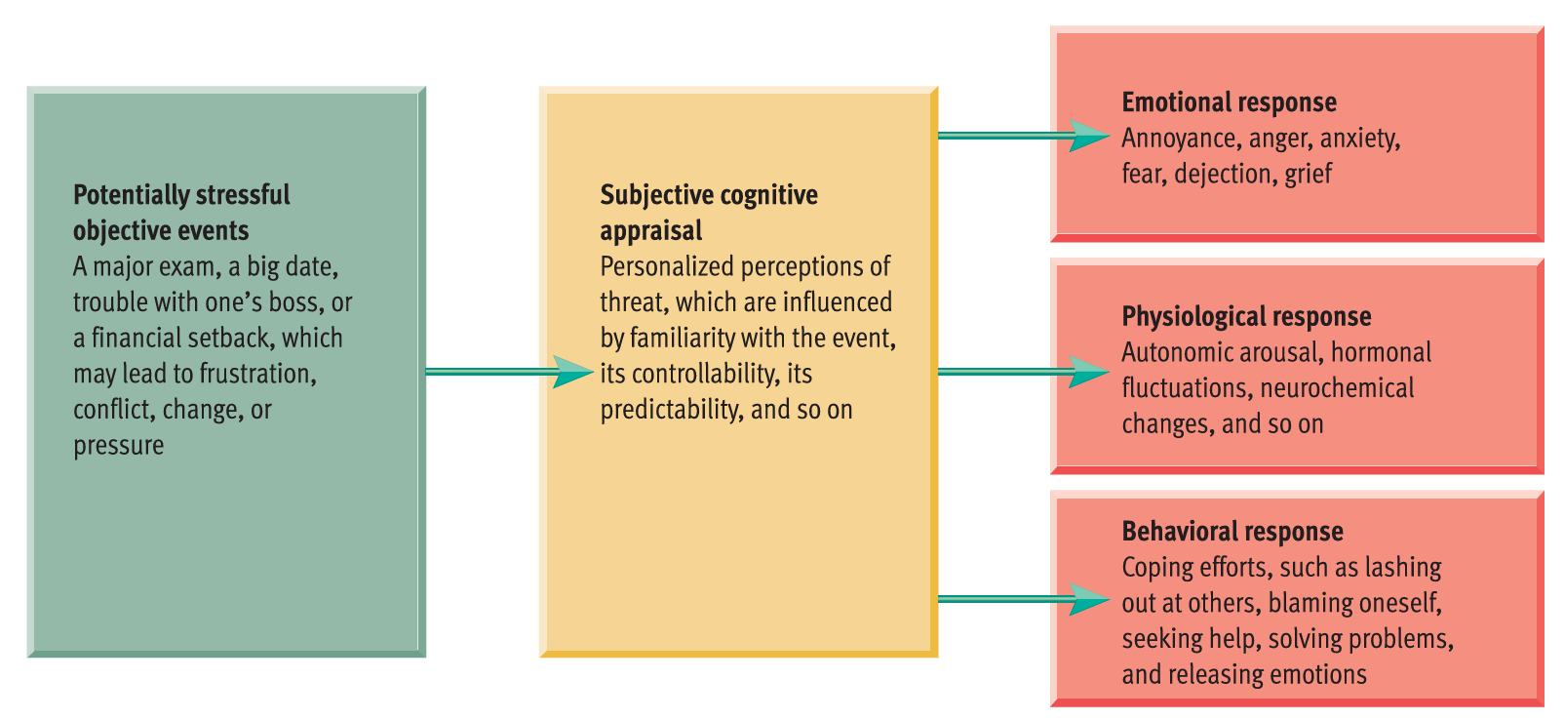

**EMOTIONAL RESPONSE**

Self-blame tends to lead to guilt, helplessness to sadness, and so forth. When people face stress, their emotions tend to fall into three main categories:

1. **Annoyance, anger, and rage**
2. **Apprehension, anxiety, and fear**
3. **Dejection, sadness, and grief**

Even though stress is usually linked to negative emotions, people can also feel **positive emotions** during tough times. For example, after the 9/11 attacks, while many Americans experienced anger, sadness, and fear, they also felt gratitude, love for family and friends, and appreciation for their blessings. These positive emotions were more common in people who showed greater **resilience**—the ability to bounce back from hardship.

**Why Positive Emotions Matter**

1. They expand our thinking, making us more creative and flexible when solving problems.
2. They reduce the lasting effects of negative emotions, easing the harmful physical reactions to stress.
3. They strengthen relationships and social support, which builds long-term resources for coping.

**Benefits of Positive Emotions**

* Make people more open-minded and creative.
* Help them cope better with challenges.
* Improve emotional well-being, leading to better mental health.
* Lower stress hormones and even reduce the risk of death in some cases.
* Boost the immune system, making people less likely to get sick. For example, a study found that people with a positive attitude were less likely to catch a cold or flu after being exposed to the virus.

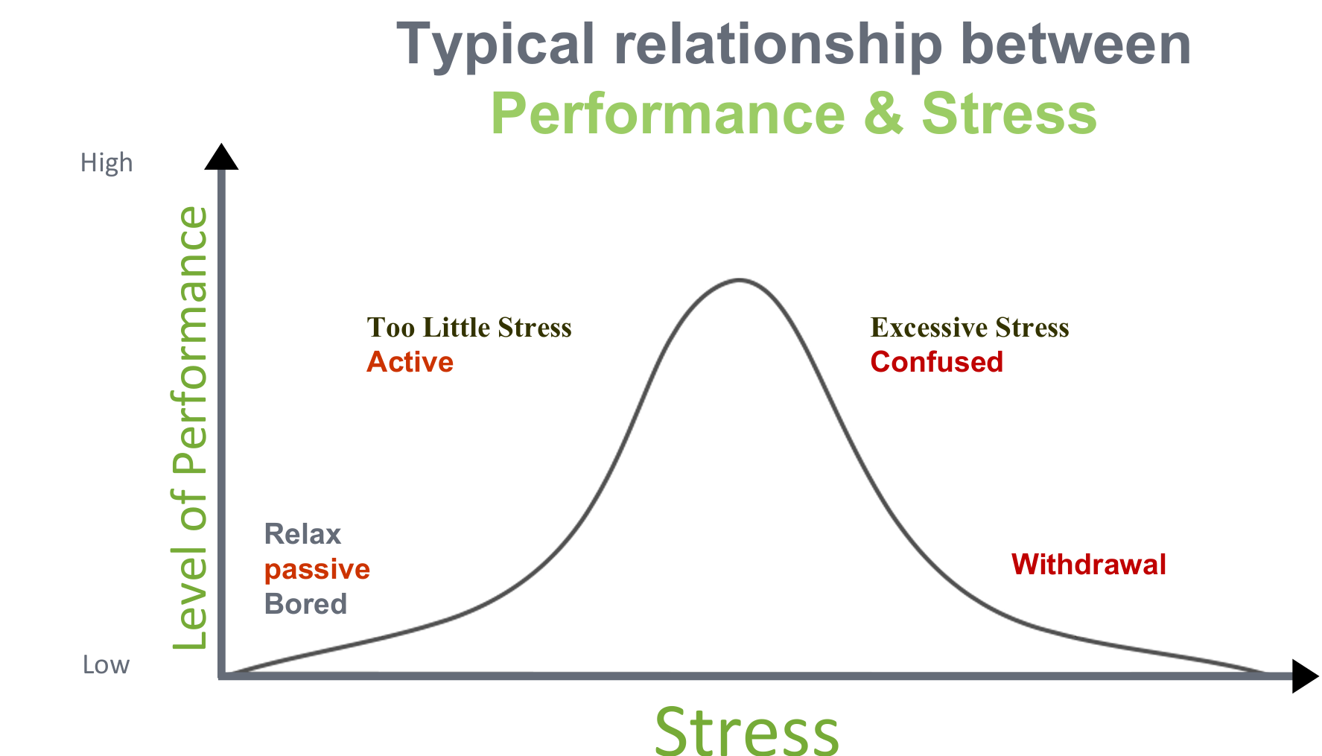

**Task Complexity and Arousal**

The ideal amount of emotional arousal depends on how complex the task is:

* **Simple tasks** (e.g., driving to help a friend in a crisis) require higher levels of arousal to perform well.
* **Complex tasks** (e.g., making an important decision) require lower levels of arousal for peak performance because too much excitement can overwhelm your ability to think carefully.

**PHYSIOLOGICAL RESPONSES**

The Fight-or-Flight Response: The fight or-flight response is a physiological reaction to threat in which the autonomic nervous system mobilizes the organism for attacking (fight) or fleeing (flight) an enemy.

**Modern Implications**

While this response was crucial for survival in early human history, it is less adaptive today for dealing with modern stressors like work or financial challenges. For these, more nuanced responses are required.

**Gender Differences**

Shelley Taylor and colleagues propose an alternative for females, called the **"tend-and-befriend" response**, due to their evolutionary role in caring for offspring. Instead of fighting or fleeing, females are more likely to seek social support and care for their young. Although the stress-response mechanisms are similar across genders, this behavior highlights evolutionary adaptations.

**The General Adaptation Syndrome**

The general adaptation syndrome is a model of the body’s stress response, consisting of three stages: alarm, resistance, and exhaustion.

1. **Alarm Stage**: The body recognizes a threat, triggering physiological arousal akin to the fight-or-flight response.
2. **Resistance Stage**: If stress persists, the body stabilizes and adapts, maintaining heightened arousal to cope with the stressor.
3. **Exhaustion Stage**: Chronic stress depletes the body's resources, leading to health issues like **"diseases of adaptation"** caused by overactivation of stress responses.\

**BEHAVIORAL RESPONSES:**

Emphasizes how coping strategies significantly impact individuals' ability to manage stress effectively. It categorizes coping mechanisms into adaptive and maladaptive strategies, highlighting the consequences of each approach.

**1. Coping as a Behavioral Response:** Coping involves active efforts to manage, reduce, or tolerate the demands created by stress. These efforts can be adaptive (helpful) or maladaptive (harmful).

* Examples of Adaptive Coping**:** Studying harder or seeking help when failing a course.
* Examples of Maladaptive Coping**:** Blaming others or giving up without trying.

**2. Flexibility in Coping:**

Flexibility in coping means changing how you deal with stress depending on the situation. If you adjust your approach based on whether the problem is within your control or not, you’re more likely to handle stress better. For example, if something can be fixed, like improving your grades, you might work harder. If it can't be changed, like bad weather ruining plans, you might accept it and move on. Being flexible like this helps reduce stress levels in your body and can even improve your health.

**3. Maladaptive Coping Strategies:**

Maladaptive Coping Strategies are unhealthy ways of dealing with stress. Here are some examples explained simply:

1. Learned Helplessness: “Learned helplessness is passive behavior produced by exposure to unavoidable aversive events.” This happens when people give up because they feel they can’t control a bad situation. For example, if someone fails a test and decides there's no point in studying anymore, they stop trying. This mindset is often linked to depression because it makes people feel hopeless.
2. Blaming Oneself: Some people are very hard on themselves when things go wrong. This is called "catastrophic thinking," where they believe everything is their fault and the situation is worse than it really is. Over time, this can make their stress worse and even lead to depression.
3. Aggression: Aggression is any behavior that is intended to hurt someone, either physically or verbally. When stressed, some people lash out at others, even at those who aren’t the cause of their frustration (like yelling at a friend after a bad day at work). Freud believed releasing anger in this way could help, but research shows it often just makes people angrier and doesn't solve the problem.
4. Self-Indulgence: Stress can make people lose control of their impulses. This might include overeating, drinking too much alcohol, using drugs, or spending money on things they don’t need to feel better temporarily. While these behaviors might offer quick comfort, they usually create more problems in the long run.

**4. Modern Maladaptive Behaviors:**

* **Internet Addiction:** Excessive online activity can become a coping mechanism, disrupting daily functioning and creating dependency. While debated, it highlights the evolving nature of stress responses.

**Personal Coping Strategies:** Trust in time. Don't isolate yourself. Think positively. Keep a sense of humour. Think about yourself as relaxed. Exercise and get a pet. No drug or alcohol use. Eating breakfast. Maintaining normal weight. Getting adequate sleep. Regular exercise. Eating Regular meals

**Defensive Coping**

These strategies protect us from unpleasant emotions like anxiety or guilt but often distort reality and don’t solve the actual problem. They can be unhealthy if used excessively. They shield us from feeling overwhelmed by emotions like anger, anxiety, or guilt. They work through **self-deception**. For example:

* + If you’re failing in school, you might **deny** the seriousness of the situation or imagine unrealistic ways to fix it. These actions reduce anxiety temporarily but don’t solve the issue.

**Are they conscious or unconscious?** Both. Some defenses happen without you realizing it, while others are more deliberate.

**Are they healthy?** Most of the time, no. They avoid dealing with the real problem. However, **small positive illusions** (e.g., being slightly over-optimistic) can sometimes boost confidence and mental well-being. Extreme distortions, like complete denial of reality, are harmful.

**Constructive Coping**

These are healthier ways to handle stress and involve realistic, proactive efforts to address challenges.

1. **Key Features of Constructive Coping:**
   * **Problem-solving focus:** Face issues head-on by evaluating your options and taking action.
   * **Realistic thinking:** Avoid excessive self-deception or negativity. Some positivity is good, but ignoring reality isn’t.
   * **Emotional regulation:** Learn to manage intense emotions caused by stress, so they don’t overwhelm you.
   * **Physical well-being:** Take care of your body to reduce the impact of stress (e.g., sleep well, exercise, eat healthily).
2. **Does it always work?**  
   Not always. Even the best strategies can fail depending on the situation, but constructive coping generally improves your chances of managing stress effectively.

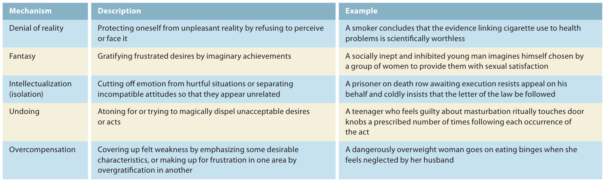

**Anger & its types**

1. Anger is “an emotional state that varies in intensity from mild irritation to intense fury and rage”
2. Anger is defined as a natural, adaptive response to threats

Types of anger: People use a variety of both conscious and unconscious processes to deal with their angry feelings. The three main approaches are expressing, suppressing, and calming

1. **Assertive anger (expressing)**

Expressing your angry feelings in an assertive—not aggressive—manner is the healthiest way to express anger. To do this, you have to learn how to make clear what your needs are, and how to get them met, without hurting others. Being assertive doesn’t mean being pushy or demanding; it means being respectful of yourself and others.

1. **Passive anger (calming)**

This type of anger calms down inside. This means not just controlling your outward behavior, but also controlling your internal responses, taking steps to lower your heart rate, calm yourself down, and let the feelings subside.

1. **Passive-aggressive anger (suppressing)**

Unexpressed anger can create many problems. It can lead to pathological expressions of anger, such as passive-aggressive behavior (getting back at people indirectly, without telling them why, rather than confronting them head-on) or a personality that seems perpetually cynical and hostile. People who are constantly putting others down, criticizing everything, and making cynical comments haven’t learned how to constructively express their anger. Not surprisingly, they aren’t likely to have many successful relationships.

**Causes of anger**

A number of factors can cause a person to be angry such as:

* Genetic or physiological factor: There is evidence that some children are born irritable, touchy, and easily angered, and that these signs are present from a very early age.
* Sociocultural: Anger is often regarded as negative; we’re taught that it’s all right to express anxiety, depression, or other emotions but not to express anger. As a result, we don’t learn how to handle it or channel it constructively.
* Research has also found that family background plays a role. Typically, people who are easily angered come from families that are disruptive, chaotic, and not skilled at emotional communications.

**Management of anger**

The goal of anger management is to reduce both your emotional feelings and the physiological arousal that anger causes. Following are the techniques used for anger management: Relaxation, Cognitive Restructuring (changing the way you think), Problem solving, Using humor, Better communication, Changing your environment, Finding alternatives, Avoidance (Don’t make yourself look at what infuriates you), Timing (try changing the times when you talk about important matters so these talks don’t turn into arguments.)

**Factors moderating the impact of Stress**

People vary in how well they tolerate stress due to moderator variables like social support, optimism, and conscientiousness. Social support, including emotional aid from friends and family, is linked to better immune function and overall health. Positive social interactions help buffer stress, while social conflicts can increase illness risk. Optimism, the tendency to expect good outcomes, is associated with better health by promoting adaptive coping strategies like problem-solving and seeking support. Pessimism, in contrast, often leads to unhealthy coping like denial or giving up. Conscientiousness, a personality trait, has been linked to longevity due to healthier behaviors and better stress management.

Behavioral factors like smoking, nutrition, and exercise play a significant role in health. Smoking remains a major health risk, contributing to diseases like cancer, heart disease, and lung conditions. Poor nutrition also influences health, with diets high in cholesterol, salt, and unhealthy fats increasing the risk of cardiovascular diseases.

**Chapter 14: Psychological Disorders**

**Normality:** The World Health Organization (WHO) considers normality to be a state of complete physical, mental and social well-being.

**Abnormality:** Abnormal behavior is generally defined as behavior that causes people to experience distress and hinders them from functioning in their daily lives.

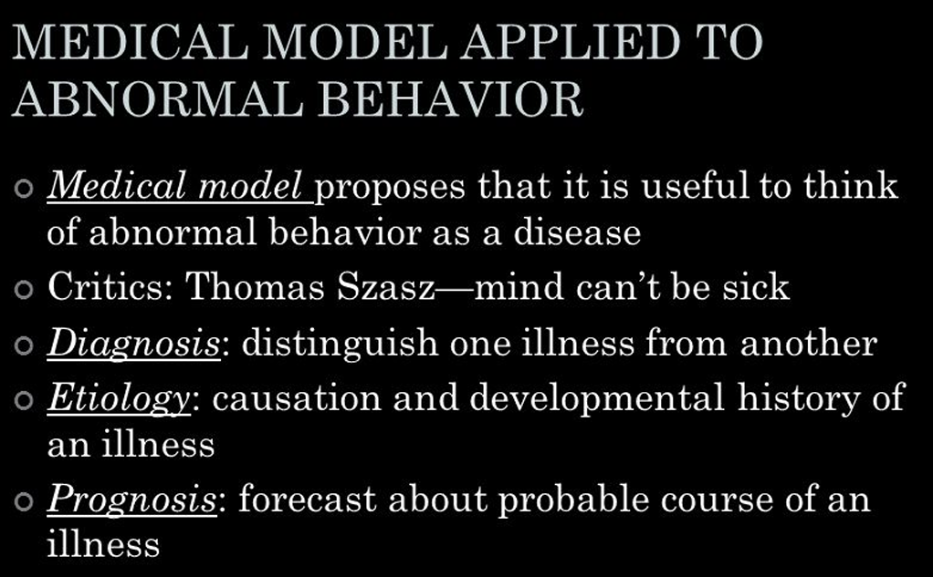

**Criteria for judging is behavior is abnormal:**

1. **Deviance:** Abnormal behavior is often considered when someone’s actions don’t match society’s norms. What is considered normal varies by culture, but behaviors that violate societal expectations can be labeled as mentally ill. For example, transvestic fetishism, a sexual disorder where a man is aroused by wearing women's clothing, is seen as deviant because it contradicts cultural norms.
2. **Maladaptive Behavior:** This criterion refers to behavior that impairs a person’s ability to function in everyday life. For example, using drugs might not be abnormal, but if it starts to affect work or relationships, it becomes a problem.
3. **Personal Distress:** Many psychological disorders are diagnosed based on the individual's subjective report of distress. For instance, someone experiencing depression or anxiety might not show obvious deviant or maladaptive behavior but will be diagnosed based on their self-reported suffering.

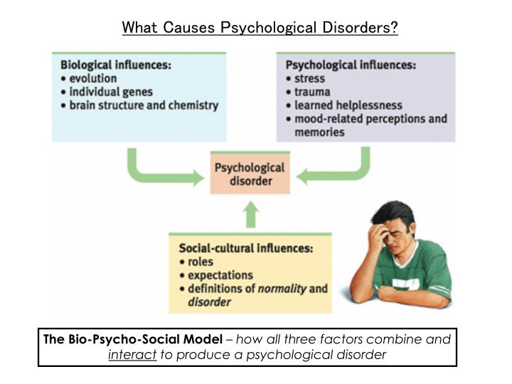

**Biological influences:**

* **Evolution:** Genetic and evolutionary factors may influence the likelihood of developing certain psychological disorders**.**
* **Individual genes:** Specific genetic traits may predispose someone to certain mental health issues.
* **Brain structure and chemistry:** Differences or imbalances in brain structure or neurotransmitters can contribute to psychological disorders.

**2. Psychological influences:**

* **Stress:** Life stressors, such as work, relationships, or personal challenges, can trigger or worsen mental health issues.
* **Trauma:** Experiences of trauma (like abuse or a life-threatening event) can have lasting psychological effects.
* **Learned helplessness:** When individuals feel they have no control over their situation, it can lead to feelings of hopelessness and mental health struggles.
* **Mood-related perceptions and memories:** How a person perceives and remembers events can impact their mental state. For example, a negative outlook or trauma-induced memories can contribute to psychological disorders.

**3. Social-cultural influences:**

* **Roles:** The societal roles people are expected to play (e.g., parent, employee) can cause stress if they feel overwhelmed or unable to meet those expectations.
* **Expectations:** Society’s expectations of how people should behave or succeed can impact mental health, especially if a person feels they’re falling short.
* **Definitions of normality and disorder:** Cultural definitions of what is considered "normal" or "abnormal" can affect how people perceive their own behavior and mental health.

**The classification of psychological disorders**:

**Neurosis**: Anxiety Disorders, Somatoform Disorder, Dissociative Disorders, Mood Disorders

**Psychosis**: Schizophrenia

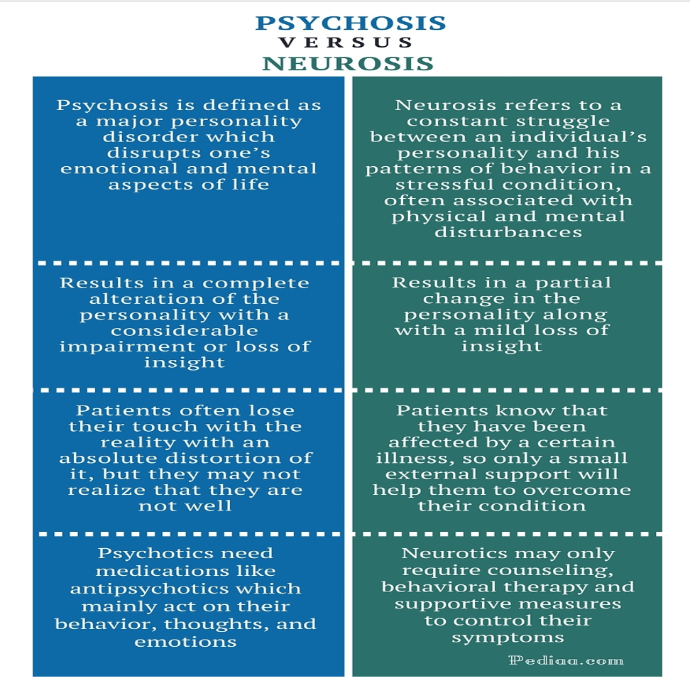

**ANXIETY DISORDER:** Anxiety disorders are a class of disorders marked by feelings of excessive apprehension and anxiety.

1. **Generalized Anxiety Disorder (GAD)**

Generalized Anxiety Disorder is marked by a persistent and excessive level of anxiety that is not linked to any specific threat. Individuals with GAD constantly worry about a range of issues, including minor matters related to family, finances, work, or health. Ironically, many believe that their worrying can prevent negative events, though this leads them to worry even about their worrying. Physical symptoms, such as trembling, muscle tension, dizziness, faintness, sweating, and heart palpitations, often accompany the anxiety. GAD starts gradually and has a lifetime prevalence of around 5%, occurring more frequently in females than males.

1. **Phobic Disorder**

Phobic Disorder involves an intense, irrational fear of specific objects or situations that pose no actual danger. While mild phobias are common, a diagnosis of Phobic Disorder is made only when the fear significantly interferes with daily functioning. Phobias can trigger physical symptoms, such as trembling and heart palpitations.

Types: Acrophobia (fear of heights), Claustrophobia (fear of small, enclosed places) Brontophobia (fear of storms), Hydrophobia (fear of water), Zoophobia (fear of animals), Microphobia (fear of germs), Aerophobia (fear of flying/ airplane), Arachnophobia (fear of spiders), Hemophobia (fear of blood), Pathophobia (fear of disease)

**Panic Disorder and Agoraphobia**

Panic Disorder is characterized by sudden, recurring panic attacks that bring overwhelming anxiety and physical symptoms. After experiencing multiple panic attacks, individuals may develop a fear of future episodes, leading to heightened apprehension and avoidance behaviors.

This avoidance can result in Agoraphobia, where individuals fear public or open places and may become confined to their homes. While traditionally viewed as a separate phobic disorder, Agoraphobia is now often seen as a complication of Panic Disorder. Panic Disorder typically begins in late adolescence or early adulthood and affects more females than males, with about two-thirds of cases occurring in women.

1. **Obsessive-Compulsive Disorder (OCD)**

Obsessive-Compulsive Disorder (OCD) is marked by persistent, uncontrollable intrusions of unwanted thoughts (obsessions) and urges to engage in senseless rituals (compulsions). For example, someone obsessed with cleanliness may compulsively wash their hands or clean objects.This disorder often results in severe social and occupational impairments, as compulsive behaviors can consume much of an individual’s time and energy.

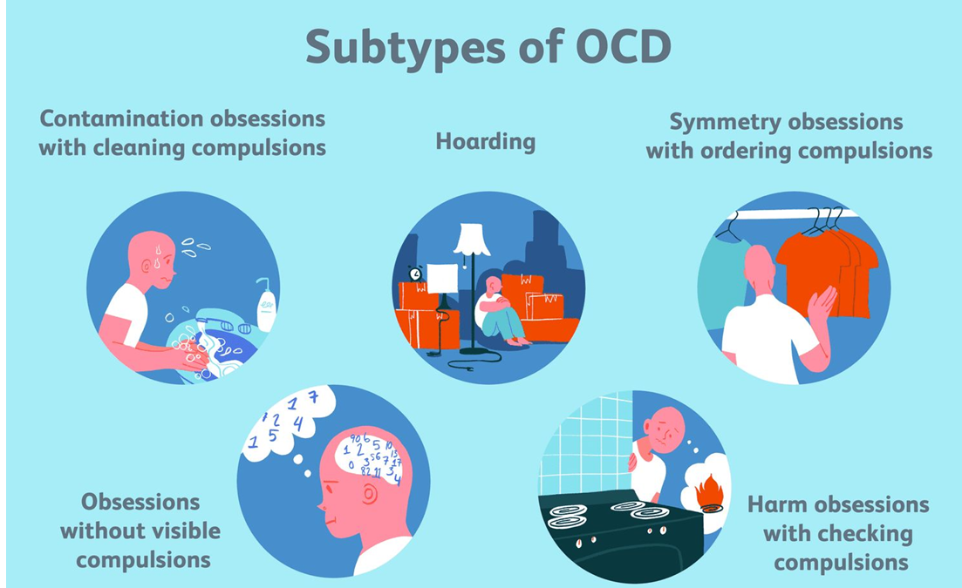

1. **Post-Traumatic Stress Disorder (PTSD)**

Post-Traumatic Stress Disorder (PTSD) is a serious psychological condition that arises from enduring significant traumatic events. PTSD gained prominence due to the harrowing experiences of Vietnam War veterans, who struggled with the emotional and psychological aftermath of combat. However, research has since demonstrated that PTSD is not limited to war experiences; it can also result from various traumatic events such as rape, assault, severe automobile accidents, natural disasters, or witnessing death.

Individuals suffering from PTSD often experience a range of debilitating symptoms. These include recurrent flashbacks and nightmares that force them to relive the traumatic event, emotional numbness, feelings of alienation, and difficulties in social relationships. They may also experience heightened vulnerability, along with increased levels of arousal, anxiety, anger, and guilt. The persistent nature of these symptoms can severely disrupt personal and professional lives.

**Treatment of anxiety disorders:**

Exposure therapy: This is a kind of behavioral therapy that involves gradually confronting the source of your anxiety in order to break the cycle of avoidance.

Psychotherapy: Specific psychotherapy approaches such as cognitive behavioral therapy (CBT) in a group or individual setting may be helpful with phobias.

Prescribed medications: These include antidepressants, and anti-anxiety medications

Relaxation techniques: Examples are breathing techniques and mindfulness exercises

**Somatoform Disorders:** A mental disorder characterized by a group of conditions in which the physical pain and symptoms a person feels are related to psychological factors.

1. **Somatization Disorder**A somatization disorder is marked by a history of diverse physical complaints that appear to be psychological in origin.
2. **Conversion Disorder**

* Conversion Disorder is characterized by a significant loss of physical function (with no apparent organic basis), usually in a single organ system.

1. **Hypochondriasis**

* Hypochondriasis (more widely known as hypochondria) is characterized by excessive preoccupation with one’s health and incessant worry about developing physical illnesses.

**DISSOCIATIVE DISORDER**

1. **Dissociative Amnesia**: Sudden inability to recall important personal information, often tied to traumatic events (e.g., disasters, abuse, or accidents). Memory loss can be limited to a specific event or encompass a broader period.
2. **Dissociative Fugue**: More extreme than amnesia, it involves losing all personal identity, including one’s name, family, and life history, while retaining general knowledge (e.g., driving, arithmetic).
3. **Dissociative Identity Disorder (DID)**: Formerly known as multiple personality disorder, DID involves two or more distinct personalities within the same individual. These personalities often differ drastically in traits, behaviors, and even demographic attributes like age or gender. DID frequently co-occurs with anxiety, mood, or personality disorders.

Dissociative amnesia and fugue are usually attributed to excessive Stress, Dissociative Identity Disorder caused by media,Childhood trauma (physical and sexual abuse), Childhood history of rejection from parents

**MOOD DISORDERS**

1. **Major Depressive Disorder (MDD):**

* A mood disorder marked by prolonged and intense feelings of sadness, despair, and lack of interest in activities once enjoyed.
* **Symptoms**: Emotional: Persistent sadness, hopelessness, irritability, and feelings of worthlessness. Physical: Fatigue, changes in appetite, disrupted sleep patterns, and reduced energy. Cognitive: Difficulty concentrating and frequent thoughts of death or suicide.
* Affects twice as many women as men, partly due to societal pressures, role constraints, and biological factors.
* **Duration and Recurrence**: Episodes typically last about six months.

1. **Bipolar Disorder**

* A mood disorder involving alternating periods of depression and mania.
* **Symptoms**: Manic Episodes: Euphoria, high energy, rapid speech, impulsivity, and reduced need for sleep. Depressive Episodes: Similar symptoms to MDD.
* **Prevalence**: Affects 1%–2.5% of the population equally among men and women.

Etiology involves the following:

1. Genetic vulnerability

2. Neurochemical factors (imbalance in the levels of neurotransmitters norepinephrine, serotonin)

3. Cognitive factors (pessimistic style, hopelessness, learned helplessness)

4. Interpersonal roots (inadequate social skills )

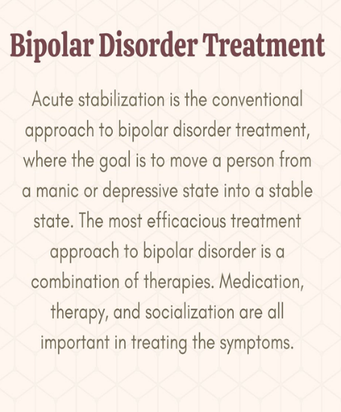

**SCHIZOPHRENIA**

* meaning "split mind," refers to fragmented thought processes

**Symptoms:**

* + **Delusions:** Persistent false beliefs, such as delusions (e.g., believing one is a famous figure)
  + **Hallucinations:** these are sensory perceptions that occur in the absence of a real, external stimulus.
  + **Disorganized Speech/Thought:** Chaotic or illogical thoughts, as seen in Sylvia's case where her ideas were wildly disconnected.
  + **Deterioration in Behavior:** Includes poor personal hygiene, inability to maintain relationships, or neglect of responsibilities.
  + **Disturbed Emotions:** lack of emotional response or inappropriate emotional reactions.

**Positive vs. Negative Symptoms:**

* + **Positive Symptoms:** Behavioral excesses, such as delusions, hallucinations, and bizarre behaviors.
  + **Negative Symptoms:** Behavioral deficits, such as social withdrawal, apathy, and impaired attention.

**Course and Outcome:**

* + Schizophrenia is typically a chronic illness with varying degrees of severity. Positive symptoms may respond better to treatment, while negative symptoms are harder to manage.

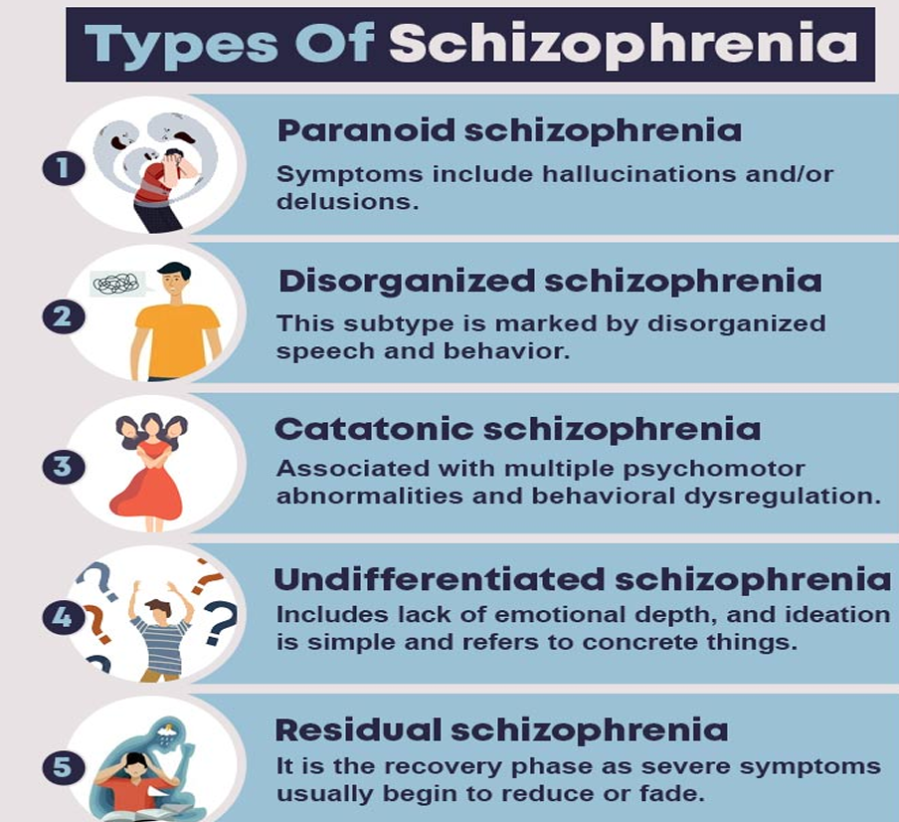 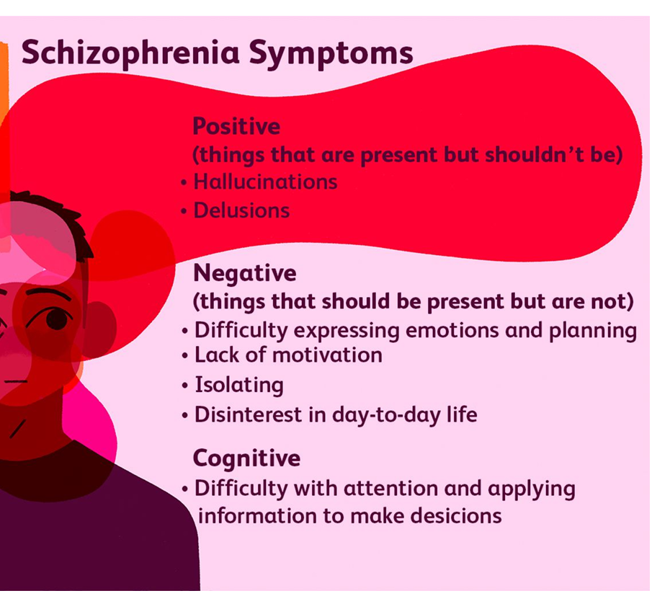

ETIOLOGY:

**Biological factors involve**: 1. Genetic Vulnerability 2. Neurochemical Basis (excessive release of Dopamine) 3. Structural Abnormalities in brain: enlarged brain ventricles

**Psychological Factors involve:** 1. Expressed Emotions (in families) 2. High Stress 3. Neurodevelopmental hypothesis: insults to the brain during prenatal development or at birth

**PERSONALITY DISORDERS**

These disorders are marked by extreme, inflexible personality traits that cause distress or impaired functioning. They typically emerge during childhood or adolescence and continue into adulthood.

* **Narcissistic Personality Disorder**: People with this disorder think they are very important. They are obsessed with being successful and expect special treatment from others. They don’t show much care for how others feel.
* **Borderline Personality Disorder**: People with this disorder have trouble keeping a stable sense of who they are. Their moods and relationships can change quickly and unpredictably. They may act impulsively without thinking things through.
* **Antisocial Personality Disorder**: People with this disorder often break rules and hurt others without feeling guilty. They don’t care about social norms or making lasting, healthy relationships. They can be reckless and may even harm others for personal gain. 